David Kolb and Alice Kolb Experiential Learning
Their works draws from the intellectual origins of experiential learning works of John Dewey, Kurt Lewin, Jean Piaget and Lev Vygotsky. A common usage of the term “experiential learning” defines learning in which the learner is directly in touch with the realities being studied. It is contrasted with the learner who only reads about, hears about, talks about, or writes about the realities. In this view of experiential learning, the emphasis is often on direct sense experience and in-context action as the primary source of learning. Many schools add classroom experiential learning exercises to add a direct experience component to their traditional learning.
The slides identify a cycle of learning beginning with experiencing and the roles a teacher takes on in the cycle.
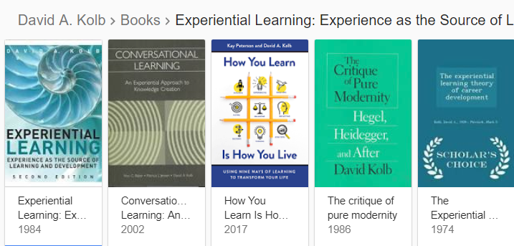
Full Cycle Learning by Kolb 2018

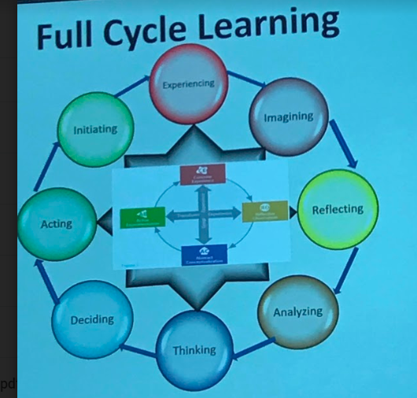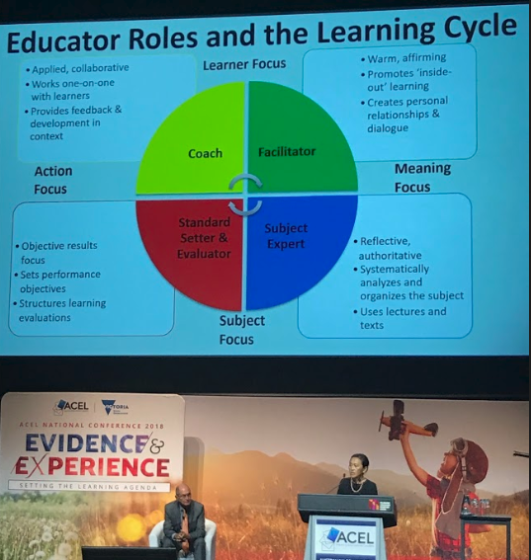
Educator roles in the learning cycle.
Lynn Sharrat Faces on the data.
We have worked with Lynn’s “Faces on the data” for the last 3 years, so it was great to be reminded of her 14 improvement parameters which she then detailed with a focus on shared beliefs and shared responsibility and understanding. Expectations and differentiation are the imperatives.
The 14 parameters of improvement
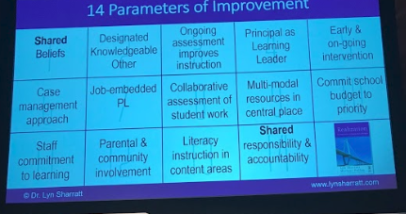
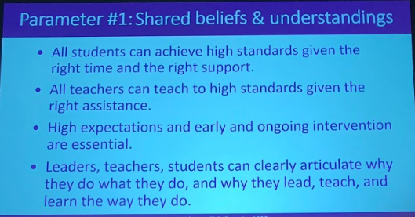

Sharrat continued.
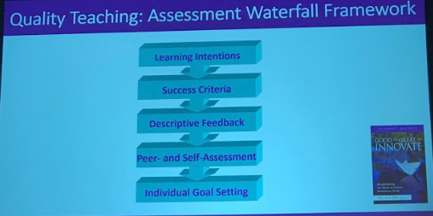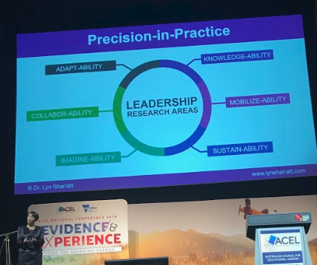
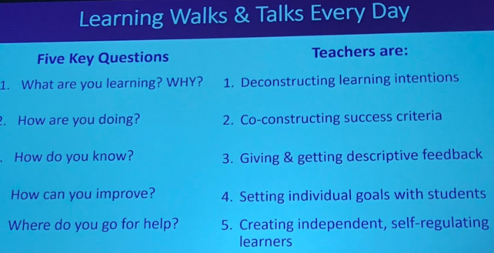
Lynn’s dialogue dove-tailed with Hattie, Hargreaves and Goodwin’s thinking. Children need to know what success for them looks like. She believes if children get descriptive, focussed on improvement feedback (same for teachers) they are most likely to feel successful.
She talked about the coaching questions teachers and leaders need to develop. These fit closely with our coaching development.
Sharrat works with children in remote parts of Australia and Canada.

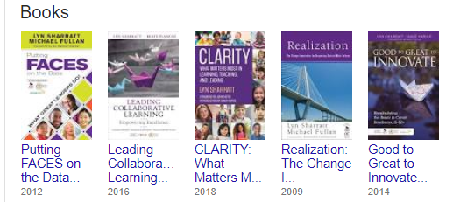
Lynn supports that notion that teachers really do matter.They help create within their classrooms the innovation mindset.
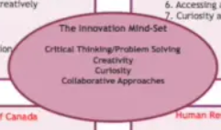
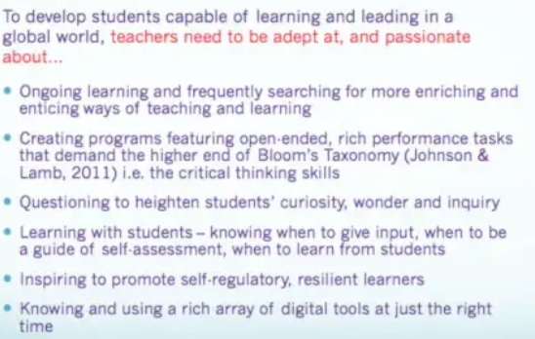

Bryan Goodwin CEO McREL- Flipping the curriculum with curiosity
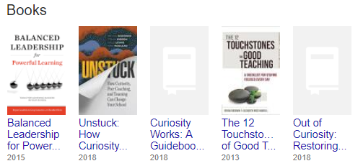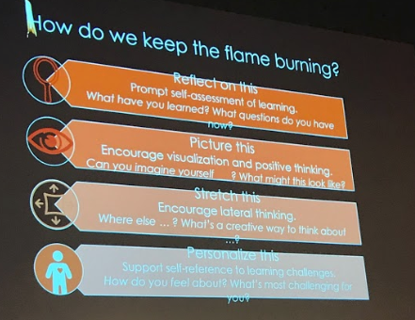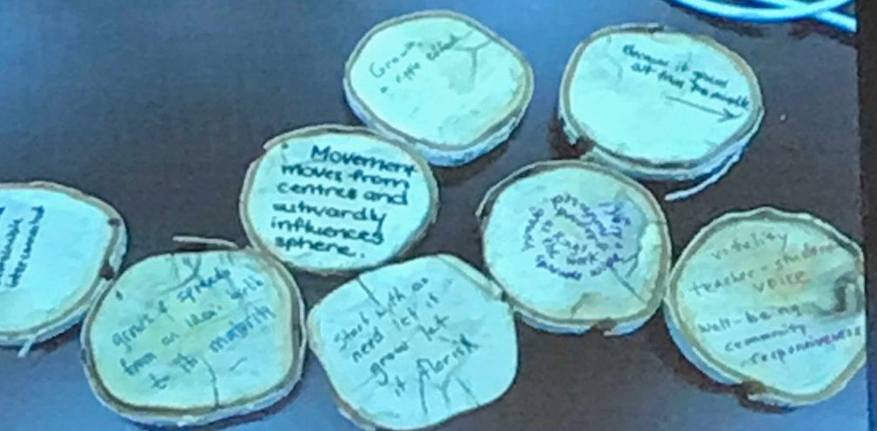
“What if all our students came to school eager to learn, self-motivated, and passionate? What if they were, in a word,
curious? And what if we could also unleash educators’
professional curiosity, tapping into the yearning professionals
feel not just to survive, but to thrive in what we do? Wouldn’t our classrooms be happier and more productive?” ( Goodwin, 2018)

We learn what we think about!
Everyday we want to ask questions that build curiosity. We need to ensure we keep children’s curiosity alive; to sustain curiosity and help learners see the purpose. Dweck’s ‘Growth Mindset’ has to be a key driver.
This exercise was about the curiosity of considering growth of trees through growth rings. Here a teacher cut up a branch and children wrote down how they saw the growth- so fitting with experiential and academic learning through curiosity.
Curiosity kept alive provides more positive life outcomes according to the McCREL research and yet we see children at 2years of age full of curiosity but by 12 years a 40 % decrease. We have to actively promote curious behaviours and Goodwin’s leading from the inside0-out provides a platform to ensure that happens in our schools.

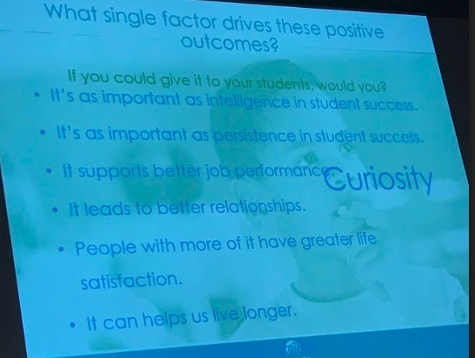

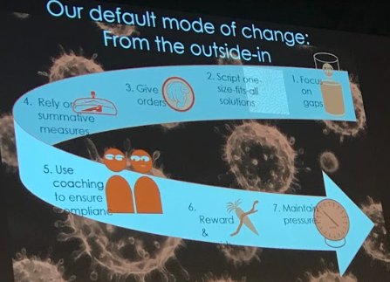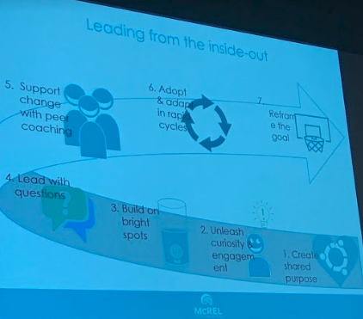

Robert Biswas Diener
Robert started with asking us to consider a traffic infringement we had received- a ticket, speeding etc. He then asked us to talk about the why’s of the infringement and who or what was responsible. It was clear that all the infringements fitted with either blame of self, blaming another person, blaming the environment. He then introduced the levels of analysis as a way of looking at why we do things the way we do.
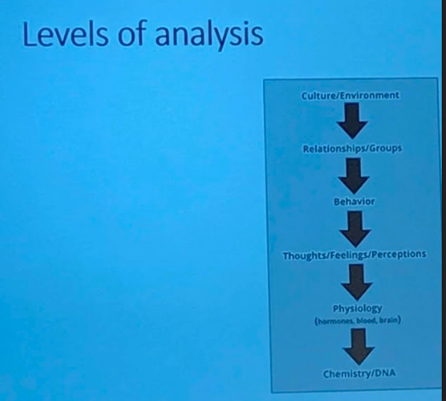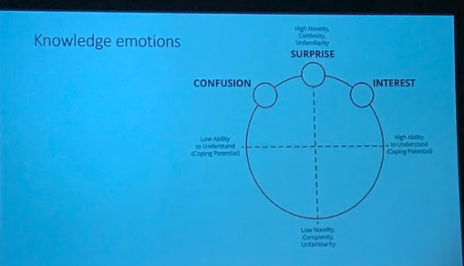
Boredom
Boredom
It is the culture or environment.
It is my relationships or a groups I belong to that mean I act a certain way.
My behaviour determines actions.
My thoughts and feelings make me want to do something……
Robert discussed being more aware of why we do things. He said we need
to know if it is our environment; our DNA or our feelings for example that influence what and why we do things. That, in our schools we need to ensure high levels of novelty, complexity and unfamiliarity to spark learning. Goodwin might call that keeping up curiosity. Robert looked at environments where things become totally familiar, have low novelty and low complexity e.g. rote learning or regurgitated learning which lead to boredom.
Schools need to build emotional activity into learning and use the emotion levels to set expectations. WE need to teach children how to move out of confusion to interest . It is not about giving more novelty it is about ensuring learning has some novelty/ something new.
He recommended looking at the work of John Monro from the University of Melbourne with a particular focus on his work with gifted students and differentiated programmes that are based on high interest.
https://research.acer.edu.au/cgi/viewcontent.cgi?article=1144&context=research_conference
Elizabeth Ross Hubbell
Her message was about being intentional in what we do. She conducts workshops and training for teachers on research-based instructional strategies and technology integration.
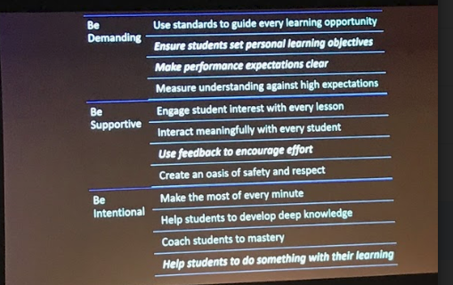
Prof.John Hattie
We enjoyed seeing John’s focus on impact as a key determinant of learning.
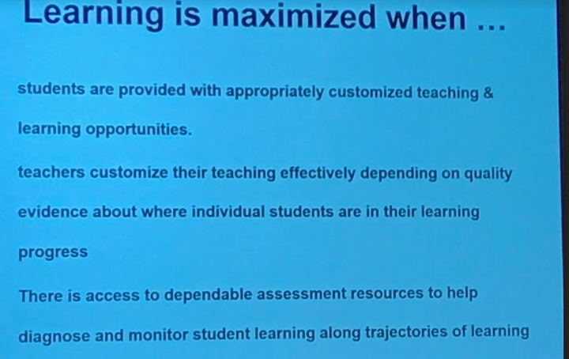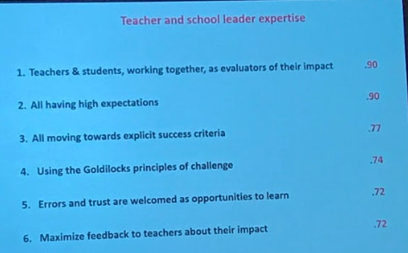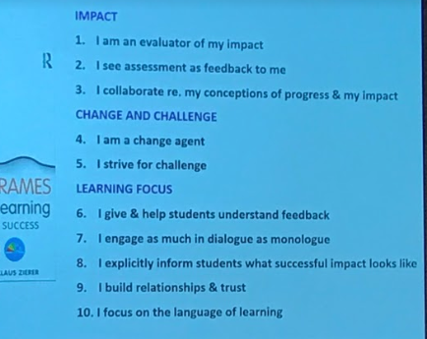
Hattie talked about collective efficacy and the need for schools to develop peer learning; to improve students seeking feedback. He wanted the key message in schools to be to capture children’s thinking. We need to enhance the expertise of teachers and we need politicians to be consulting with leadership groups like ACEL. He felt some good things were happening in Australia.
He referenced the AITSL Standards:-
https://www.aitsl.edu.au/teach/standards
and talked about the Gonski reports, in particular the latest report that considered excellence in schooling https://docs.education.gov.au/node/50516. The report has 3 priorities focussed on strengthening learning across all schooling.
Priority one: Deliver at least one year's growth in learning for every student every year. Priority two: Equip every child to be a creative, connected and engaged learner in a rapidly changing world. Priority three: Cultivate an adaptive, innovative and continuously improving education system.
The Review Panel also recommended strengthening the attractiveness of the teaching and school leadership professions by creating clearer career pathways, better recognising expertise, and strengthening workforce planning and development.
Great article about making learning visible.
The big ideas are –
Know thy impact! Expert teachers are not wedded to specific teaching strategies. Rather, they regularly focus on
evaluating the effects, they have on students, and adjust teaching methods accordingly.
Learning impact was greatest with teachers with the most passion as set out in the 7cs of care, control, clarify, challenge, captivate, confer, and consolidate.
Wouldn’t it be great if every child could pinpoint exactly where they were with their core learning and what they needed to do to improve- see the reading pillar on the left.
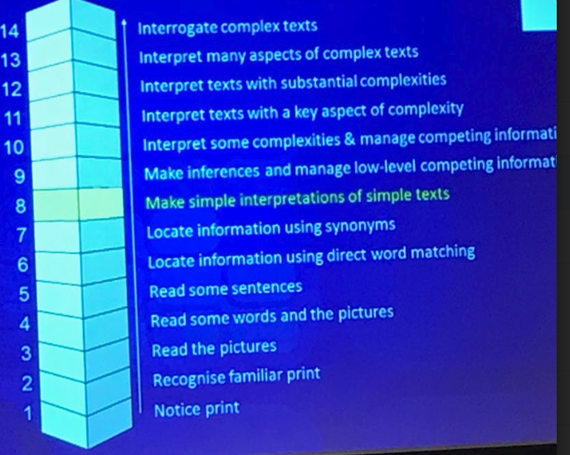
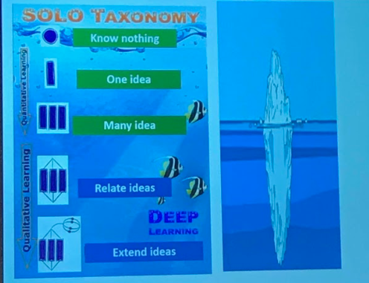
Hattie values Solo for the notion of surface and deep thinking and learning. It is a simple but effective way of identifying learning.
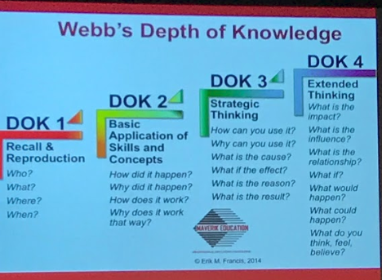
Hattie also referenced Webb’s DOK and School Venture’s Australia as having a way to consider improvement in teaching and learning in our schools.
We need clear planning identifying inputs and outputs if we are to consider impact.
